Flow Chart Diagram
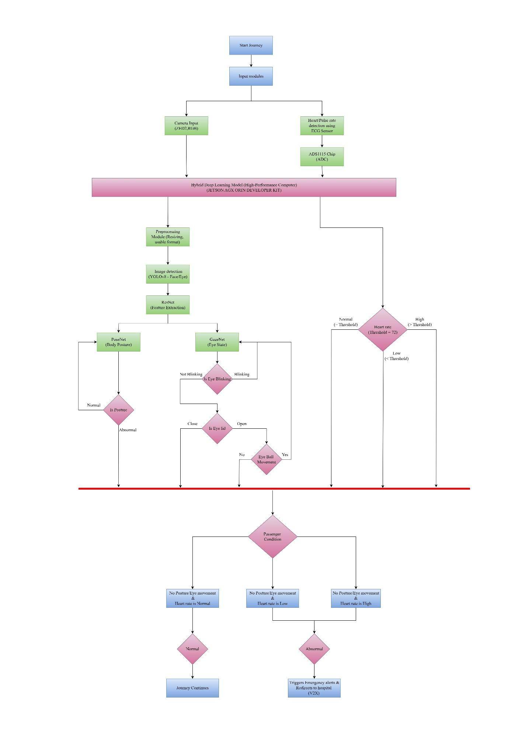
Fig: Flow Chart approach for passenger health monitoring in a semi-autonomous vehicle
The flowchart represents the in-Cabin Monitoring Safety System in semi-autonomous vehicles. The safety monitoring begins when a journey starts, and the input modules, such as the ZED2 camera and ECG sensor, are initialized. The ZED2 camera provides RGB frames in real-time, whereas the ECG sensor collects the passenger's heart rate and pulse, which is integrated in the seatbelt.
The data is being pre-processed (resizing and converting to usable formats). After pre-processing is done, YOLOv8 detects the passenger face and presence. Once the face/body has been detected, ResNet, which processes passenger face/body features, is used as a backbone for GazeNet, which classifies the Passenger's eye state as open or closed and also confirms this with the eyeball movement. In addition to eye state, PoseNet is responsible for analysing passenger body posture and detecting when unconsciousness or unusual body positions occur.
Input module fusion is done on the Jetson AGX Orin SDK, then the detection systems determine the overall condition of the passenger. In a normal situation where posture is stable, heart rate is steady, and eye activity is natural, the journey proceeds as usual. When the system detects an abnormal situation, closed eyes and abnormal heartbeat, no body movement with abnormal vitals, and loss of pulse, the system activates emergency alerts via V2X communication and autonomously redirects the vehicle to the Hospital.

